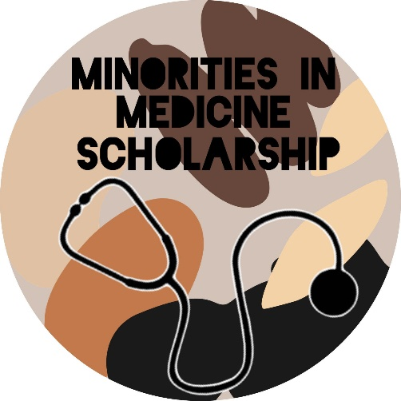
Overview: The Abrazo Emergency Medicine program is excited to announce the Minority In Medicine (MIM) scholarship, an initiative aimed at recruiting quality fourth year medical students whose race and/or ethnicity has historically been underrepresented in medicine. Our program strongly believes that our physician population should reflect our patient population and that addressing racial injustice in the healthcare system starts with us – residency programs training the next generation of physicians. In order to help accomplish this, we recognize the need for targeted recruitment efforts as well as the offering of financial assistance to offset the costs of traveling to the Phoenix area for your one-month rotation. For the upcoming application cycle, we are offering a $500 scholarship to an eligible student.
Eligibility
- African American, Native American and Hispanic American medical students are invited to apply.
- Students should be fourth year medical students in good standing from an accredited M.D. or D.O. program.
- Students should be applying for residency training in Emergency Medicine.
- Students should meet all eligibility requirements as outlined in the Application for Medical Student Rotation form.
Application:
- Students must be willing to identify their race and/or ethnicity as African American, Native American or Hispanic American.
- Students must submit essay responses no longer than 750 words each to the following prompts:
  - What challenges have you faced on your road to becoming a physician?
  - How do you hope to help your community once you are in residency and beyond?
  - What would receiving this scholarship mean to you?
- Upload your essay using our google form at our website, WVEM.org under Minorities in Medicine

